Assessment Task for Listening & Integrated Skills
Topic: Overseas School Trip

Data File

Contents

 |  | Page
1. | Note Sheet for Tasks 1 and 3 ……………………………………………................ | 2
2. | Plan for the article as suggested by Mrs. To ………………………………………. | 2
3. | Itinerary for Progress College’s trip to Vietnam ………………………………….. | 3
4. | Extract from guide book …………………………………………………………. | 3
5. | Extract from travel advertisement ………………………………………………… | 4
6. | Advertisement from magazine…………………………………………………….. | 4
7. | Report on the Pagoda School visit………………………………………………… | 5
8. | Leaflet on the one-day cookery course …………………………………………… | 5
9. | Internet chat among students who took part in the trip ………………………....... | 6
10. | Note from Mrs To about a letter from a parent……………….…………………… | 7

Data File 1
Advantages and disadvantages of school trips overseas
Write your notes for Tasks 1 and 3 here.
Advantages  -  -  -  - | Disadvantages  -  -
A point of concern to parents likely to be brought up at the PTA meeting

Data File 2
Plan for the article as suggested by Mrs. To
Add information to the plan as you listen to the meeting.
Plan of the magazine article (Use 180-200 words]
- State the basic facts of the tour (who, where, when, how long).
- Use the itinerary and mention the main places:
- Hanoi
- Halong Bay
- Ho Chi Minh City
- Give a brief introduction of Pagoda School.
- Mention the three projects we undertook.
- Briefly summarise some information about the cookery course we joined.
- Say how much we liked the local food. Mention some of the best dishes we enjoyed.
- End with the sentence: All in all, it was a great trip.
- Add an interesting title.
- Use a lively style and make the trip sound good. Use ‘we’.
Make sure you select and summarise the information needed; it’s only a short article.

Data File 3

Itinerary for Progress College’s trip to Vietnam
Day 1 | - Arrive in Hanoi, met at airport and taken to hotel; settle into the hotel and walk round local shops.
Days 2 - 3 | - Visit sights in Hanoi, including Ho Chi Minh’s Mausoleum, the House on Stilts, the Temple of Literature and the Old Quarter.
Day 3 | - Free time
Day 4 | - Halong Bay - drive to the bay and stay in a guest house overnight.
Day 5 | - Cruise round the emerald waters of the bay on an old-style junk. Visit some of the 1969 islands and enjoy the sea air. Fish dinner.
Day 6 | - Move to Ho Chi Minh City, and settle into hotel. Evening walk.
Day 7 | - See the Jade Emperor Pagoda, War Museum and Chinatown.
Day 8 | - Tour the Chu Chi Tunnels from the Independence War.
Days 9 -18 | - Work with the students at Pagoda School.
Day 19 | - Cookery Course
Day 20 | - Coach to airport for departure.
Your guide throughout the tour will be Mr. Tran Van Cong, painter as well as translator and guide. Please feel free to ask for his help in any way.

Data File 4
Extract from guide book
Cyclos, small pedalled carriages, a more modern version of the hand-pulled rickshaw, are a common sight on the streets of old Hanoi. For safety reasons they are not allowed on the busy roads with their thousands of motorbikes buzzing around, but plenty of the vehicles, painted red and often beautifully decorated, remain in quieter areas for the delight of tourists.
Picture taken by松岡明芳
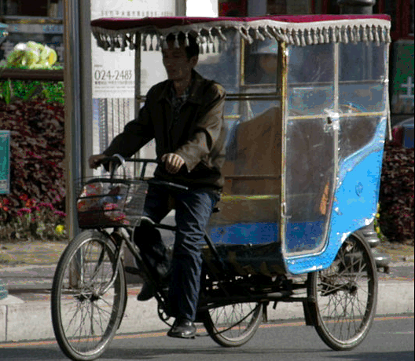

Data File 5
Extract from travel advertisement
Visit historic Vietnam
See amazing sights
- The Ho Chi Minh Mausoleum in Hanoi was built (1973-75) from materials all over Vietnam to honour the national hero, Ho Chi Minh. The impressive building stands in a fine garden and houses the hero’s body. Visitors are asked to dress respectfully. | 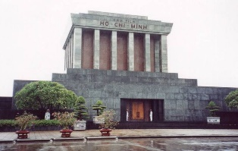Picture taken by Shermozle
- The Nine Dynastic Urns in Hue. These huge metal urns, covered in beautiful decorations, are lined up outside Mieu Temple. They were made in 1836 to celebrate the prosperity of the country and its emperors. | 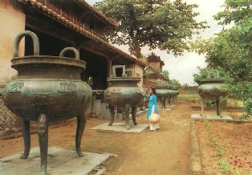
- The Thien Hau Pagoda, Ho Chi Minh City, was built in the early 19th century by the Cantonese community. It is richly decorated and contains three statues of the goddess as well as a wooden boat hanging from the ceiling. | 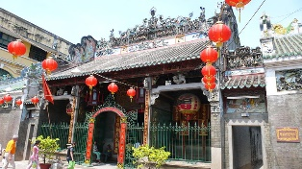Picture taken by Christopher
- The Chu Chi Tunnels are 121 kms of underground tunnels created by Vietnamese fighters. Visitors may crawl round some safe areas and some tunnels have been enlarged for Western tourists of a larger size. Some underground conference rooms have been restored and lit. | 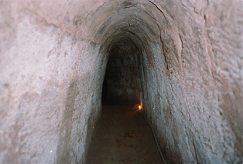

Data File 6
Advertisement from magazine
PAGODA SCHOOL
Ho Chi Minh City
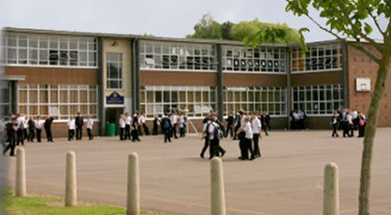
Please donate generously!
Picture taken by blackcutuk
The Pagoda School was opened in 2000. We offer a free education to children of the shantytown area of Ho Chi Minh City, whose parents cannot afford to send them to school. Our funding comes from donations, mainly from overseas. We aim to give students a balanced curriculum of academic and practical subjects so that when they leave us they will have various job options. We are particularly proud of our English language programme which opens up many opportunities for young people here in Vietnam.
Contribute now. Your money will help create a better world.
Data File 7
Report on the Pagoda School visit
When we first approached the Pagoda School in a poor area of the city consisting mainly of squatters’ huts, we felt rather nervous, but that feeling soon left when we entered the building. The principal, teachers and students were all very welcoming. The facilities are pretty basic, but everything is kept clean and tidy. We were particularly impressed by the large garden which is looked after by the students and used to grow fruit, herbs and vegetables for the midday meal which the school serves free to everyone in the school, ensuring the students get at least one decent meal a day.
We had been collecting books which we thought would be suitable for some months and the first job of some of us was to catalogue the books and get them ready for the school library. Our donation of books clearly pleased everyone.
Our daily task was to teach English. We met all the students of every age. We had received some training in advance and had a number of games and activities ready. Some worked well and others had to be changed so we were busy every night thinking of new lessons and preparing the materials.
We talked a lot about the school and brainstormed ways in which we could help. Someone suggested painting the rather plain classrooms in bright colours. We discussed the idea with the principal. He agreed at once so we collected money among ourselves and spent a Saturday afternoon and Sunday morning painting. All our efforts were rewarded by the surprised and excited smiles of the students on Monday morning!
Some people say it is a disadvantage of the school trips that they are a loss of study time, but they are also a wonderful opportunity for non-academic learning. We don’t normally paint walls at school, but actually it was an amazing learning experience.
Tommy Lo & Vanessa Tam
Data File 8
Leaflet on one-day cookery course
MEKONG Delta SCHOOL OF COOKERY
One-day course
Learn the basic skills of Vietnamese cookery
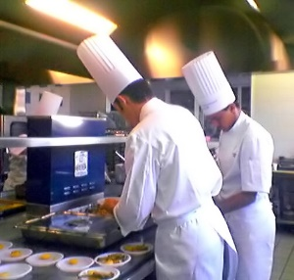
Explore the market with one of our instructors
Picture taken by David Monniaux
Prepare
- bun bo hue (spicy beef noodles)
- banh bao ( barbecue pork dumplings)
- bo bia (spring rolls, fried and fresh)
- banh mi (French style sandwiches)
- pho ga ( chicken noodle soup)

17, Cao Ba Quat St, District 1, HCMC

Data File 9

Internet chat among students who took part in the trip
 | …
Diane: | My mind is still in Vietnam. It was all so wonderful and those children! I feel they’ll be my friends for life.
Sarah: | Yes, my mum says she is pleased I went and that I am now a much more independent person.
Diane: | Yes, that is one big advantage of these trips - you have to do things for yourself and learn some independence away from Mum doing all the work and getting you ready for everything.
Noel: | I still think you were crazy going there - it’s amazing none of you were ill. Think of all the diseases you could have caught, the dangerous insects and unhygienic food. My Dad will only let us go to places with good water, fine hospitals and high standards. Dad says developing countries are a danger to health.
Sarah: | You have a point, but as none of us did fall ill you cannot claim it is that risky - and you missed some wonderful sights like Mr. Cheung covered in noodles.
Noel: | LOL - what happened?
Sarah: | We went on this cookery course and Mr. Cheung tried to show off how he could toss the noodles up in the air and catch them. But he couldn’t and they were all over him - luckily they weren’t hot!
Guy: | They were very nice at that cookery school, weren’t they?
Diane: | My favourite person was our guide, Mr. Tran - he was just so kind!
Guy: | Yes, he never showed any impatience - and, as you say, very kind.
Sarah: | Everyone was kind apart from that bad-tempered cyclo driver, but the guide was the kindest.
Harry: | Here are the results of my e-survey on the groups favourite Vietnamese food:  - Banh mi – the best sandwiches ever!  - Spring rolls in all their different forms  - Rice with clams  - Barbecue pork dumplings  - Pho
Guy: | Well, I can say one big advantage of the trip has been our increased cultural awareness. I know some Vietnamese phrases (I keep on wanting to say Chao, Cam on, Tot and Xin Loi), and some Vietnamese history and I can cook Vietnamese food!
Noel: | Hey, what do those mean?
Guy: | Hi, thank you, good and excuse me.
Diane: | I wonder where next year’s trip will be to?
 | …

Data File 10

Note from Mrs. To about a letter from a parent
Dear Sandra,

Sorry to give you one more job but I must go to a meeting and I need this for this evening. A parent has written to the principal about a number of matters. Below are a couple of paragraphs referring to our school trips overseas. Please help me prepare a short survey to get the opinions of the parents at tonight’s PTA meeting. I want to ask about the points I have underlined. Please keep the questions short and simple wh-/how ones.

Let me now turn my attention to the matter of the school trips overseas. I have a number of points to make about them. First, they seem to be going further and further away from Hong Kong. I think the destinations should be kept close to Hong Kong. Then, the trips should be shorter in duration than they are now.

It is my opinion that they are too expensive too. Putting a child through school is already a costly business and this is just an extra burden. It might even be a good idea to have the trips less often – you could have them every two or three years. I think many parents too would prefer the trips to be in the Easter holiday. And every trip should have a sports side to it as parents regard sending their children on such trips as a way of keeping them fit*.

By the way, I vaguely remember we mentioned a point at our meeting which we thought parents might bring up at the PTA meeting. Do you remember what it is? Can you turn it into one of our survey questions?

*I doubt if this is the real reason they send them. Please find out what others think.

END OF DATA FILE

DATA FILE
(Teacher’s copy)
Contents

 |  | Page
1. | Note Sheet for Tasks 1 and 3 ……………………………………………................ | 2
2. | Plan for the article as suggested by Mrs. To ………………………………………. | 2
3. | Itinerary for Progress College’s trip to Vietnam ………………………………….. | 3
4. | Extract from guide book …………………………………………………………. | 3
5. | Extract from travel advertisement ………………………………………………… | 4
6. | Advertisement from magazine…………………………………………………….. | 4
7. | Report on the Pagoda School visit………………………………………………… | 5
8. | Leaflet on the one-day cookery course …………………………………………… | 5
9. | Internet chat among students who took part in the trip ………………………....... | 6
10. | Note from Mrs To about a letter from a parent…………………………………… | 7

Annotated Data File

Data File 1
Advantages and disadvantages of school trips overseas
Write your notes for Tasks 1 and 3 here.
Advantages  -  -  -  - | Disadvantages  -  -
A point of concern to parents likely to be brought up at the PTA meeting

Data File 2
Plan for the article as suggested by Mrs. To
Add information to the plan as you listen to the meeting.
Plan of the magazine article [Use 180-200 words]
- State the basic facts of the tour [who, where, when, how long].
- Use the itinerary and mention the main places:
    - Hanoi
    - Halong Bay
    - Ho Chi Minh City
- Give a brief introduction of Pagoda School.
- Mention the three projects we undertook.
- Briefly summarise some information about the cookery course we joined.
- Say how much we liked the local food. Mention some of the best dishes we enjoyed.
- End with the sentence: All in all, it was a great trip.
- Add an interesting title.
- Use a lively style and make the trip sound good. Use ‘we’.
Make sure you select and summarise the information needed; it’s only a short article.

Data File 3
Itinerary for Progress College’s trip to Vietnam
Day 1 | - Arrive in Hanoi, met at airport and taken to hotel; settle into the hotel and walk round local shops. | Task 2 – main places
Days 2 - 3 | - Visit sights in Hanoi, including Ho Chi Minh’s Mausoleum, the House on Stilts, the Temple of Literature and the Old Quarter. | Task 2 – main places
Day 3 | - Free time
Day 4 | - Halong Bay - drive to the bay and stay in a guest house overnight.
Day 5 | - Cruise round the emerald waters of the bay on an old-style junk. Visit some of the 1969 islands and enjoy the sea air. Fish dinner. | Task 2 – main places
Day 6 | - Move to Ho Chi Minh City, and settle into hotel. Evening walk. | Task 2 – main places
Day 7 | - See the Jade Emperor Pagoda, War Museum and Chinatown.
Day 8 | - Tour the Chu Chi Tunnels from the Independence War. | Task 2 – main places
Days 9 - 18 | - Work with the students at Pagoda School. | Task 2 – Pagoda School
Day 19 | - Cookery Course | Task 2 – cookery class
Day 20 | - Coach to airport for departure.
Your guide throughout the tour will be Mr. Tran Van Cong, painter as well as translator and guide. Please feel free to ask for his help in any way. |  | Task 2 - guide

Data File 4
Extract from guide book
Cyclos, small pedaled carriages, a more modern version of the hand-pulled rickshaw, are a common sight on the streets of old Hanoi. For safety reasons they are not allowed on the busy roads with their thousands of motorbikes buzzing around, but plenty of the vehicles, painted red and often beautifully decorated, remain in quieter areas for the delight of tourists.  Picture taken by松岡明芳 | Task2 - explain cyclos

Data File 5
Extract from travel advertisement
Visit historic Vietnam
See amazing sights
- The Ho Chi Minh Mausoleum in Hanoi was built (1973-75) from materials all over Vietnam to honour the national hero, Ho Chi Minh. The impressive building stands in a fine garden and houses the hero’s body. Visitors are asked to dress respectfully. | Picture taken by Shermozle | Task 2 - only Hanoi sight on the itinerary
- The Nine Dynastic Urns in Hue. These huge metal urns, covered in beautiful decorations, are lined up outside Mieu Temple. They were made in 1836 to celebrate the prosperity of the country and its emperors.
- The Thien Hau Pagoda, Ho Chi Minh City, was built in the early 19th century by the Cantonese community. It is richly decorated and contains three statues of the goddess as well as a wooden boat hanging from the ceiling. | Picture taken by Christopher
- The Chu Chi Tunnels are 121 kms of underground tunnels created by Vietnamese fighters. Visitors may crawl round some safe areas and some tunnels have been enlarged for Western tourists of a larger size. Some underground conference rooms have been restored and lit. |  | Task 2 - the only place on the Ho Chi Minh itinerary there is extra information on

Data File 6
Advertisement from magazine
PAGODA SCHOOL  Ho Chi Minh City  Please donate generously!  The Pagoda School was opened in 2000. We offer a free education to children of the shantytown area of Ho Chi Minh City, whose parents cannot afford to send them to school. Our funding comes from donations, mainly from overseas. We aim to give students a balanced curriculum of academic and practical subjects so that when they leave us they will have various job options. We are particularly proud of our English language programme which opens up many opportunities for young people here in Vietnam.  Picture taken by blackcutuk  Contribute now. Your money will help create a better world. | Task 2 -  information on the school’s students
Data File 7
Report on the Pagoda School visit
When we first approached the Pagoda School in a poor area of the city consisting mainly of squatters’ huts, we felt rather nervous, but that feeling soon left when we entered the building. The principal, teachers and students were all very welcoming. The facilities are pretty basic, but everything is kept clean and tidy. We were particularly impressed by the large garden which is looked after by the students and used to grow fruit, herbs and vegetables for the midday meal which the school serves free to everyone in the school, ensuring the students get at least one decent meal a day.  We had been collecting books which we thought would be suitable for some months and the first job of some of us was to catalogue the books and get them ready for the school library. Our donation of books clearly pleased everyone.  Our daily task was to teach English. We met all the students of every age. We had received some training in advance and had a number of games and activities ready. Some worked well and others had to be changed so we were busy every night thinking of new lessons and preparing the materials.  We talked a lot about the school and brainstormed ways in which we could help. Someone suggested painting the rather plain classrooms in bright colours. We discussed the idea with the principal. He agreed at once so we collected money among ourselves and spent a Saturday afternoon and Sunday morning painting. All our efforts were rewarded by the surprised and excited smiles of the students on Monday morning!  Some people say it is a disadvantage of the school trips that they are a loss of study time, but they are also a wonderful opportunity for non-academic learning. We don’t normally paint walls at school, but actually it was an amazing learning experience.  Tommy Lo & Vanessa Tam | Task2 - helping activity  Task2 - helping activity  Task2 - helping activity  Task 1 - one disadvantage and one advantage

Data File 8
Leaflet on one-day cookery course
MEKONG Delta SCHOOL OF COOKERY  One-day course  Learn the basic skills of Vietnamese cookery  Explore the market with one of our instructors  Prepare  - bun bo hue (spicy beef noodles)  - banh bao (barbecue pork dumplings)  - bo bia (spring rolls, fried and fresh)  - banh mi (French style sandwiches)  - pho ga (chicken noodle soup)  Picture taken by David Monniaux  17, Cao Ba Quat St, District 1, HCMC | Task 2 - cookery course and some local dishes

Data File 9
Internet chat among students who took part in the trip
 | …
Diane: | My mind is still in Vietnam. It was all so wonderful and those children! I feel they’ll be my friends for life.
Sarah: | Yes, my mum says she is pleased I went and that I am now a much more independent person.
Diane: | Yes, that is one big advantage of these trips - you have to do things for yourself and learn some independence away from Mum doing all the work and getting you ready for everything. | Task1 - disadvantage
Noel: | I still think you were crazy going there - it’s amazing none of you were ill. Think of all the diseases you could have caught, the dangerous insects and unhygienic food. My Dad will only let us go to places with good water, fine hospitals and high standards. Dad says developing countries are a danger to health. | Task 1 - disadvantage
Sarah: | You have a point, but as none of us did fall ill you cannot claim it is that risky - and you missed some wonderful sights like Mr. Cheung covered in noodles.
Noel: | LOL - what happened?
Sarah: | We went on this cookery course and Mr. Cheung tried to show off how he could toss the noodles up in the air and catch them. But he couldn’t and they were all over him - luckily they weren’t hot!
Guy: | They were very nice at that cookery school, weren’t they?
Diane: | My favourite person was our guide, Mr. Tran - he was just so kind! | Task 2 - guide
Guy: | Yes, he never showed any impatience - and, as you say, very kind.
Sarah: | Everyone was kind apart from that bad-tempered cyclo driver, but the guide was the kindest.
Harry: | Here are the results of my e-survey on the groups favourite Vietnamese food:  - Banh mi – the best sandwiches ever!  - Spring rolls in all their different forms  - Rice with clams  - Barbecue pork dumplings  - Pho | Task 2 - Vietnamese food
Guy: | Well, I can say one big advantage of the trip has been our increased cultural awareness. I know some Vietnamese phrases (I keep on wanting to say Chao, Cam on, Tot and Xin Loi), and some Vietnamese history and I can cook Vietnamese food! | Task 1 - advantage
Noel: | Hey, what do those mean?
Guy: | Hi, thank you, good and excuse me.
Diane: | I wonder where next year’s trip will be to?
 | …

Data File 10
Note from Mrs. To about a letter from a parent
Dear Sandra,  Sorry to give you one more job but I must go to a meeting and I need this for this evening. A parent has written to the principal about a number of matters. Below are a couple of paragraphs referring to our school trips overseas. Please help me prepare a short survey to get the opinions of the parents at tonight’s PTA meeting. I want to ask about the points I have underlined. Please keep the questions short and simple wh-/how ones.  Let me now turn my attention to the matter of the school trips overseas. I have a number of points to make about them. First, they seem to be going further and further away from Hong Kong. I think the destinations should be kept close to Hong Kong. Then, the trips should be shorter in duration than they are now.  It is my opinion that they are too expensive too. Putting a child through school is already a costly business and this is just an extra burden. It might even be a good idea to have the trips less often – you could have them every two or three years. I think many parents too would prefer the trips to be in the Easter holiday. And every trip should have a sports side to it as parents regard sending their children on such trips as a way of keeping them fit*.  By the way, I vaguely remember we mentioned a point at our meeting which we thought parents might bring up at the PTA meeting. Do you remember what it is? Can you turn it into one of our survey questions?  *I doubt if this is the real reason they send them. Please find out what others think. | Task 3 points for the survey

END OF ANNOTATED DATA FILE

